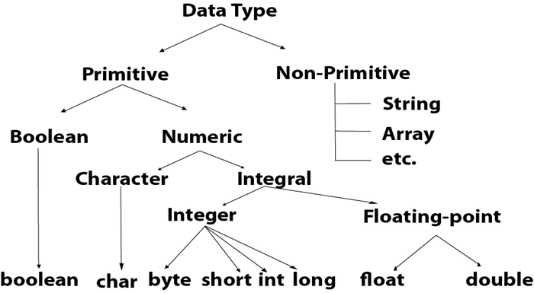

|  |  |  |
| --- | --- | --- |
| **Data Type** | **Default Value** | **Default size** |
| boolean | false | 1 bit |
| char | '\u0000' | 2 byte |
| byte | 0 | 1 byte |
| short | 0 | 2 byte |
| int | 0 | 4 byte |
| long | 0L | 8 byte |
| float | 0.0f | 4 byte |
| double | 0.0d | 8 byte |

1. **Primitive data types:** The primitive data types include boolean, char, byte, short, int, long, float and double.
2. **Non-primitive data types:** The non-primitive data types include [Classes](https://www.javatpoint.com/object-and-class-in-java)

, [Interfaces,](https://www.javatpoint.com/interface-in-java), and [Arrays](https://www.javatpoint.com/array-in-java)

